#include <iostream>

using namespace std;

void rect(void)

{

int x, y;

cout << "Enter lenght and of rectangle";

cin >> x >> y;

cout<<x*y;

}

int main()

{

rect();

system("pause");

}

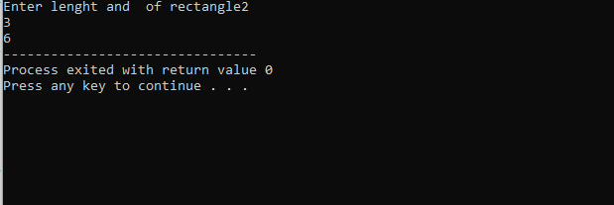

**TASK 2**

#include<iostream>

using namespace std;

void con()

{

int angle;

cout << "Enter angle";

cin >> angle;

cout << angle*(3.14 / 180);

}

int main()

{

con();

system("pause");

}

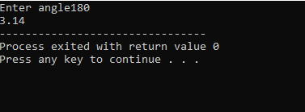

**TASK 3**

#include<iostream>

using namespace std;

void factorial()

{

int fact = 1;

int num;

cout << "Enter number for factorial";

cin >> num;

for (int i = 0; i <= num; i++)

{

fact = fact*i;

}

cout << fact;

}

int main()

{

factorial();

system("pause");

}

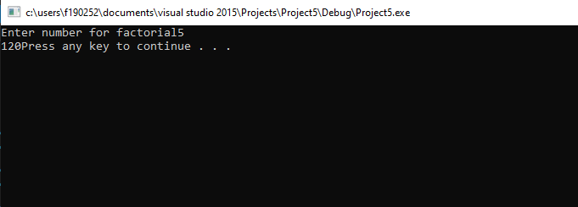

**TASK 4**

#include<iostream>

using namespace std;

void gcd()

{

int num, divisor=0,i;

cout << "Enter number";

cin >> num;

for ( i = 1; i < num; i++)

{

if (num%i == 0)

{

divisor = i;

}

}

cout << divisor;

}

int main()

{

gcd();

system("pause");

}

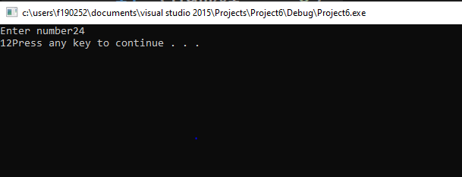

**TASK 5**

#include<iostream>

using namespace std;

int run(int radius, char option)

{

if (option == 'a')

{

int area = 3.14*radius*radius;

cout << "Area="<<area;

return area;

}

else if (option == 'c')

{

int circum = 3.14*radius * 2;

cout << "Circumference=" << circum;

return circum;

}

return 0;

}

int main()

{

int radius;

cout << "Enter radius of circle";

cin >> radius;

char a;

cout << "input character ";

cin >> a;

run( radius, a);

system("pause");

}

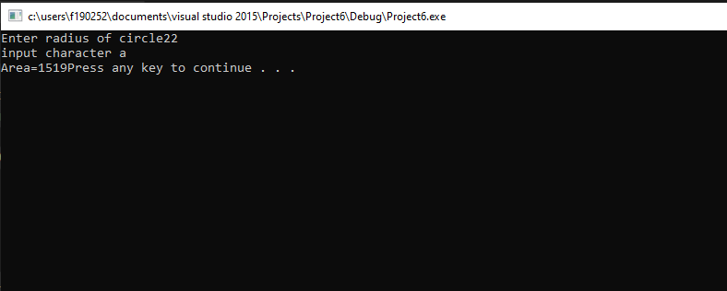

**TASK 6:**

#include<iostream>

using namespace std;

int a, b, c, d;

void encrypt()

{

int dig;

cout << "Enter four digit number";

cin >> dig;

int a = dig % 10;

int b = dig / 10 % 10;

int c = dig / 10 % 10;

int d = dig / 10 % 1;

a = a + c;

c = a - c;

a = a - c;

b = b + d;

d = b - d;

b = b - d;

cout << d << c << b << a<<endl;

}

void decrypt()

{

int dig;

cout << "Enter four digit number";

cin >> dig;

int a = dig % 10;

int b = dig / 10 % 10;

int c = dig / 10 % 10;

int d = dig / 10 % 1;

a = a + c;

c = a - c;

a = a - c;

b = b + d;

d = b - d;

b = b - d;

cout << d << c << b << a << endl;

}

int main()

{

int op;

cout << "Enter 1 for encryption and 2 for decryption ";

cin >> op;

if (op == 1)

{

encrypt();

}

else if (op == 2)

{

decrypt();

}

system("pause");

}

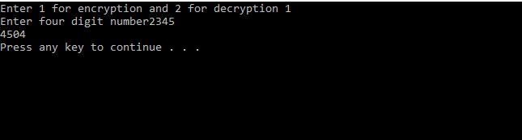

**TASK 7:**

**a)**

#include <iostream>

using namespace std;

int rect(int x,int y)

{

int result=x*y;

cout<<result;

return result;

}

int main()

{

int x,y;

cout << "Enter lenght and of rectangle";

cin >> x >> y;

rect( x, y);

system("pause");

}

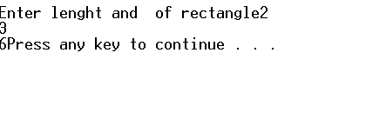

**TASK 8:**

#include<iostream>

using namespace std;

int nthterm(int N)

{

int result = (N * ((N / 2) + ((N % 2) * 2) + N));

cout << result<<endl;

return result;

}

int main()

{

int N;

cout << "Enter number ";

cin >> N;

nthterm(N);

system("pause");

}

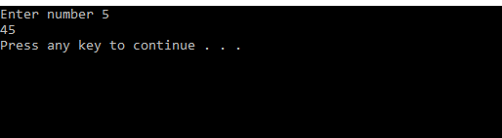

**TASK 9:**

#include<iostream>

using namespace std;

int random(int num)

{

int sum = 0;

for (int i = 1; i <=num; i++)

{

int r = rand() % 6;

sum += r;

}

cout << sum << endl;

return sum;

}

int main()

{

int num;

cout << "Enter a number ";

cin >> num;

random(num);

system("pause");

}

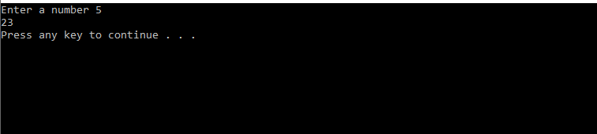

**TASK 10:**

#include<iostream>

using namespace std;

void max()

{

int num, a = 0, larger=0;

for (int i = 1; i <= 10; i++)

{

cout << "Enter number " << i<<" :";

cin >> num;

{

if (num >larger)

{

larger = num;

}

}

}

cout << larger;

}

int main()

{

max();

system("pause");

}

